PRODUCT DETAILS

**Hugo Boss Watch 1513730**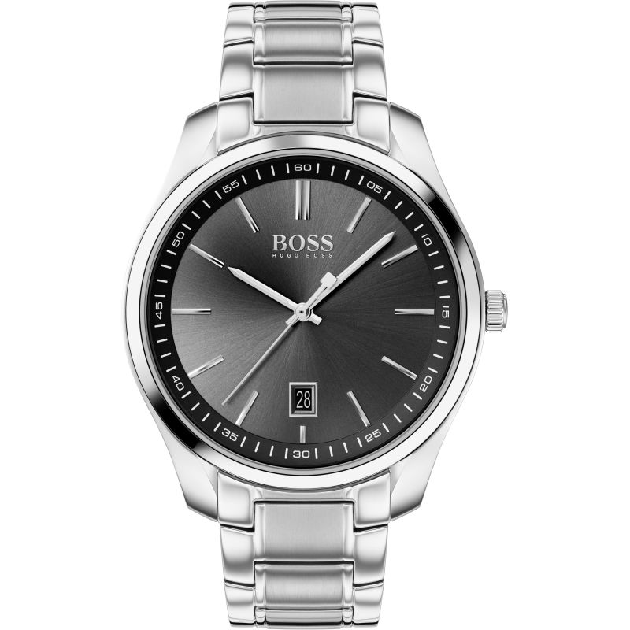

**£199.00**

**Specifications**

**Brand**: Hugo Boss

**Analogue/Digital**: Analogue

**Case depth approx**.: 7.50mm

**Primary Material**: Stainless Steel

**Case Shape**: Circle

**Case width approx**.: 42.00mm

**Clasp type**: Deployment

**Dial Colour**: Black

**Multiple Time Zones** **Display**: Dual Time

**Gender**: Gents

**Glass**: Mineral

**Model Collection**: Circuit

**Model Name**: Circuit

**Movement**: Quartz

**Strap colour**: Silver

**Strap Type**: Metal bracelet

**Water Resistance**: 30 metres

**Weight (g):** 124.00

**BARCODE**: 7613272354882

**Guarantee**: 2 years